GOEA Survey 2019 - Setting up & using Scribe:

* Unzip the Scribe 2.x.x.zip folder somewhere that you will be able to find it again.
* Run scribe.exe

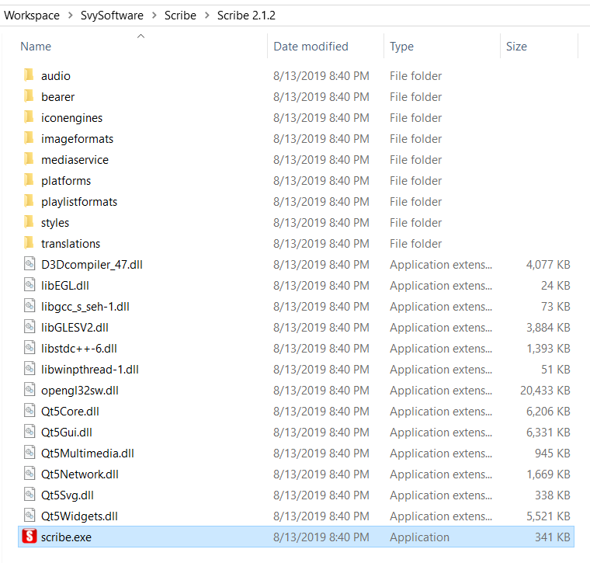

* You may see a warning message.
* Select ‘More info’ and then select ‘Run anyway’

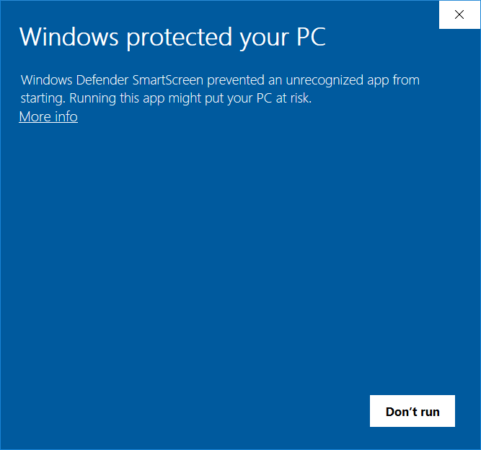 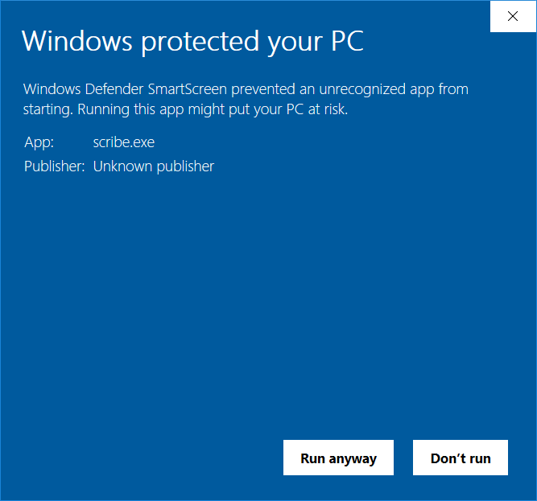

When Scribe starts up, you will see the ‘new Scribe project’ window:

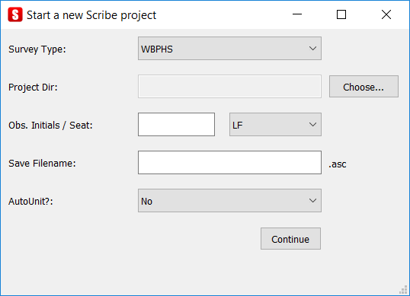

* Set ‘GOEA’ as the Survey Type
* Select the project directory where you would like Scribe to work and save files.
* Enter the crew lead initials (these initials will be appended onto the .wav file names)
* Save filename should be set to Year, Month, Day and Crew Lead Initials: e.g. 20180813TST
* Set ‘AutoUnit?’ to ‘No’
* Select ‘Continue’

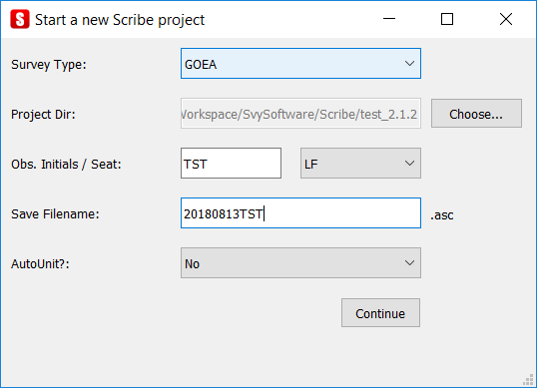

The main Scribe window should open as will the Additional Fields box:

* Don’t start to use Scribe just yet… first, import the Survey Template!
* Click on ‘File’ in the upper left
* Select Import Survey Template

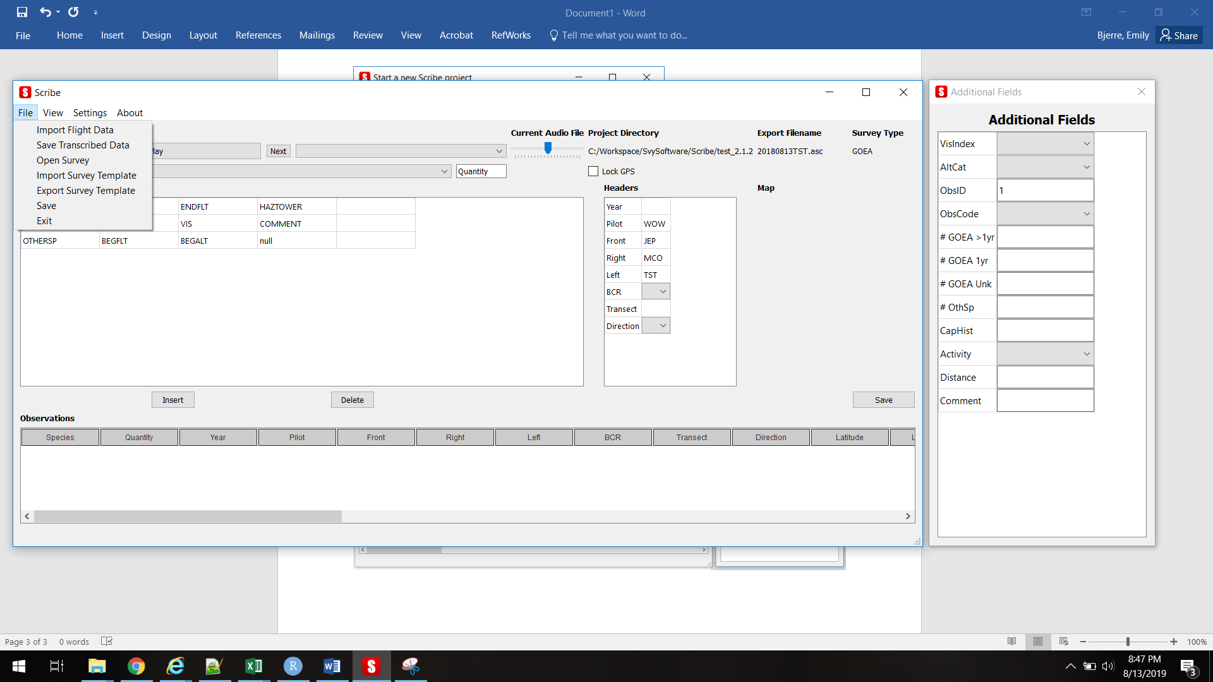

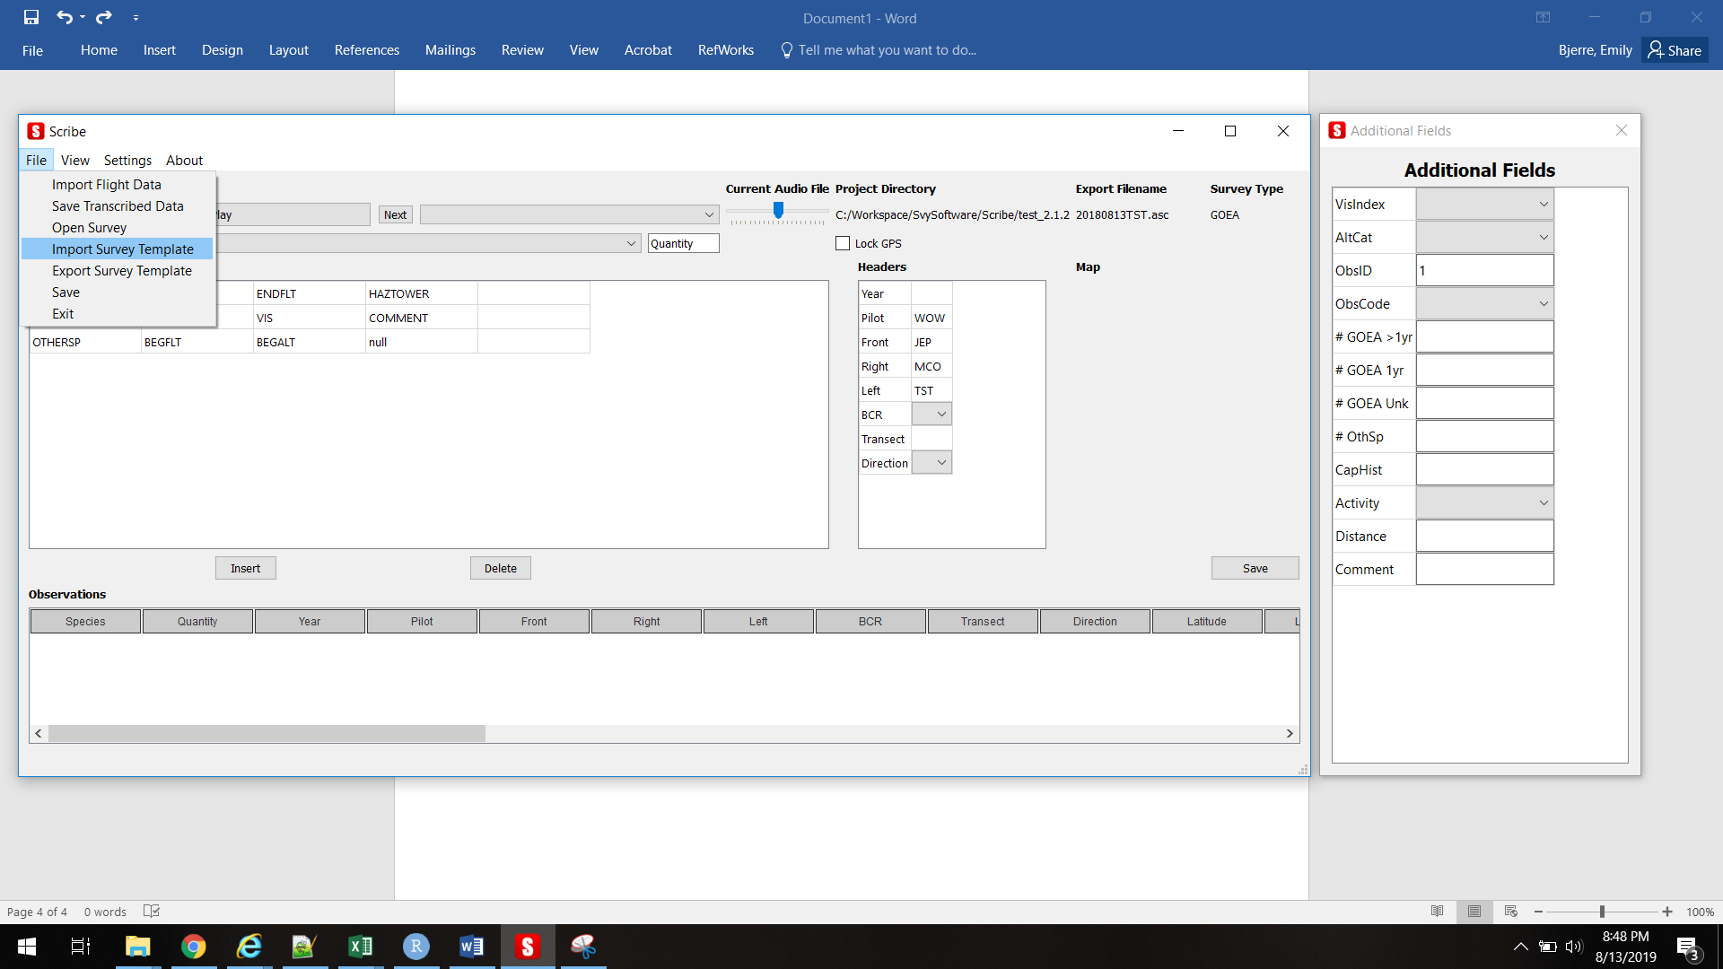

* The main Scribe window will change a little

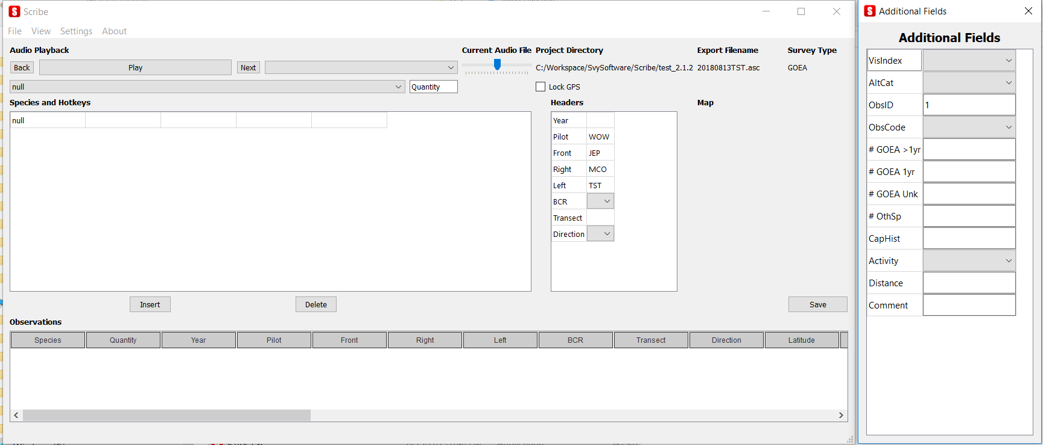

* Then Select ‘Import Flight Data’

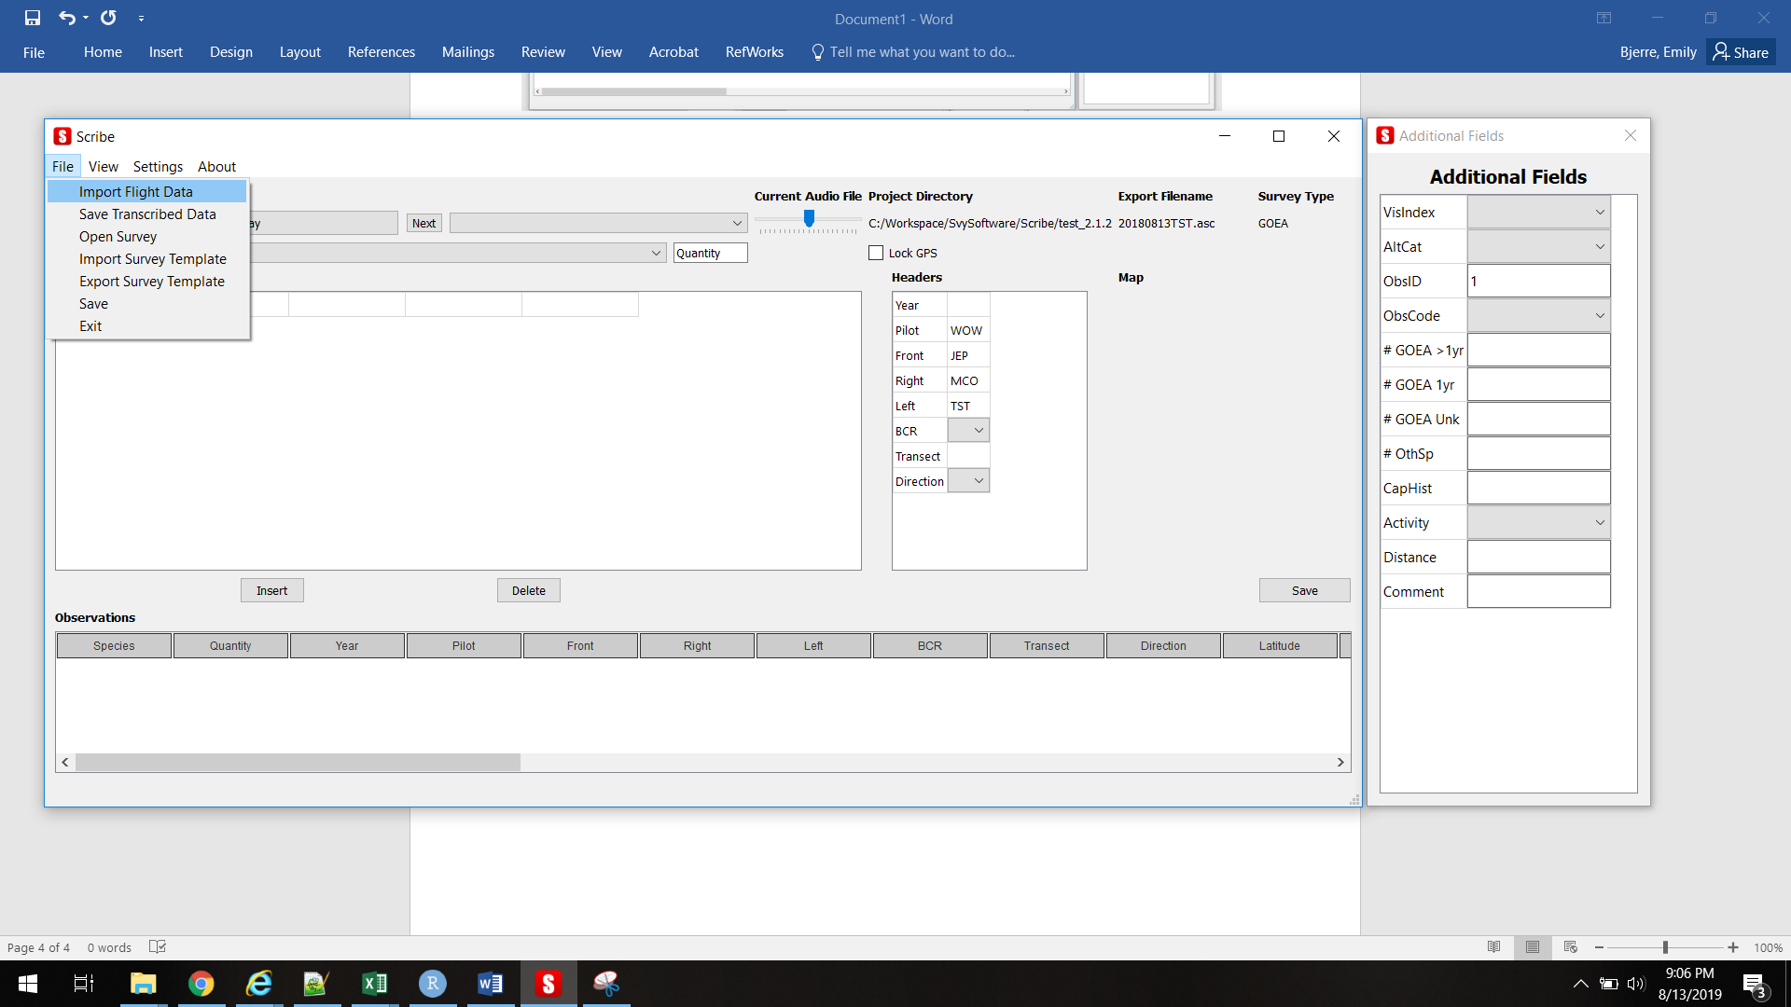

* And point Scribe to the folder where the survey files transferred from the harness are stored.

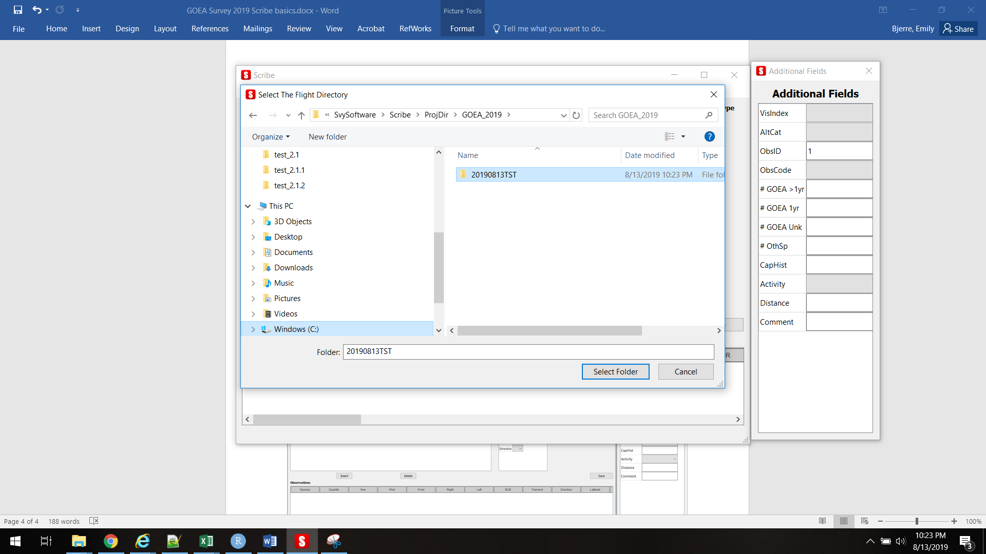

* The wav files will be renamed with the lead observer initials you entered in the start-up window (and copied into a new folder named “FlightData_[original survey data folder name]) and the ‘Year’ in the Headers section will populate base on the GPS data associated with the wav files.
* Ignore the Species and Hot Keys section and Quantity section.

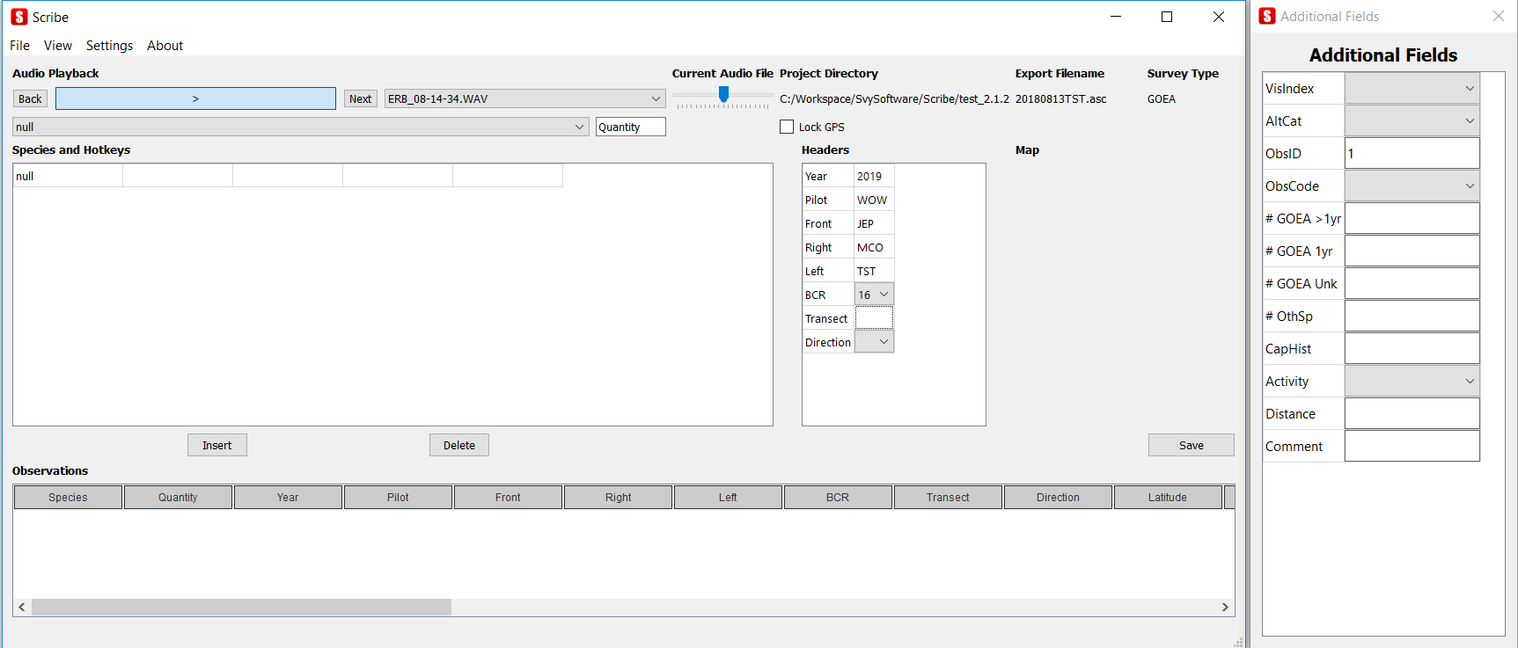

* Enter the appropriate headers in the Headers section and then forward to the first audio recording with data you wish to record.

Use ‘Lock GPS’ to hold the GPS data for one wav file while you continue to listen to other wav files and enter data.

Data may resemble something like the following:

2019,TST,JEP,MCO,WOW,,,,ERB_08-14-34.WAV,52.16560745,-106.69348145,502.8,SW,17.87,  
Thu Aug 8 08:14:33 2019 UTC-06:00,12,75,null,,,,,**BEGFLT**,,,,,,,,airport code

2019,WOW,JEP,MCO,TST,16,213,E,ERB_08-19-28.WAV,52.19427109,-106.62839508,1197.6,ESE,233.13,  
Thu Aug 8 08:19:28 2019 UTC-06:00,13,68,null,,2,107,,**BEGTRAN**,,,,,,,,transect notes

2019,WOW,JEP,MCO,TST,16,213,E,ERB_08-40-51.WAV,51.90803528,-105.24934387,1711.8,ESE,278.93,  
Thu Aug 8 08:40:50 2019 UTC-06:00,10,101,null,,2,107,1,**1ST OBS**,,,,,,,,transect notes

2019,WOW,JEP,MCO,TST,16,213,E,ERB_08-41-27.WAV,51.90234375,-105.22270966,1712.8,ESE,278.15,  
Thu Aug 8 08:41:14 2019 UTC-06:00,10,101,null,,2,107,1,**EXACT LOC**,2,1,,1,x110,Ground,200,obs notes

2019,WOW,JEP,MCO,TST,16,213,E,ERB_08-41-27.WAV,51.89938354,-105.20883942,1709.3,ESE,280.11,  
Thu Aug 8 08:41:27 2019 UTC-06:00,10,101,null,,21,107,1,**VIS**,,,,,,,,comments about vis change

2019,WOW,JEP,MCO,TST,16,213,E,ERB_08-42-20.WAV,51.88732910,-105.15330505,1709.5,ESE,281.73,  
Thu Aug 8 08:42:20 2019 UTC-06:00,10,102,null,,21,107,2,**1ST OBS**,,,,,,,,

2019,WOW,JEP,MCO,TST,16,213,E,ERB_08-42-52.WAV,51.88103104,-105.12431335,1709.1,ESE,281.73,  
Thu Aug 8 08:42:46 2019 UTC-06:00,10,102,null,,21,107,2,**EXACT LOC**,,1,,,x001,Flapping,300,

2019,WOW,JEP,MCO,TST,16,213,E,ERB_08-42-57.WAV,51.87881088,-105.11350250,1707.4,ESE,282.19,  
Thu Aug 8 08:42:56 2019 UTC-06:00,10,102,null,,21,150,,**ALT**,,,,,,,,

2019,WOW,JEP,MCO,TST,16,213,E,ERB_08-42-57.WAV,51.87881088,-105.11350250,1707.4,ESE,282.19,  
Thu Aug 8 08:42:56 2019 UTC-06:00,10,102,null,,21,150,,**ENDTRAN**,,,,,,,,